03DET22F1043

CHONG KHENG CHEN

|  |  |  |
| --- | --- | --- |
| CLO1 (C3, PLO1) | COGNITIVE ASSESSMENT  (20 %) |  |
| CLO2 (P4, PLO5) | PSYCHOMOTOR ASSESMENT  (80 %) |  |
|  | TOTAL MARKS  (100%) |  |

**\*Refer to Rubric**

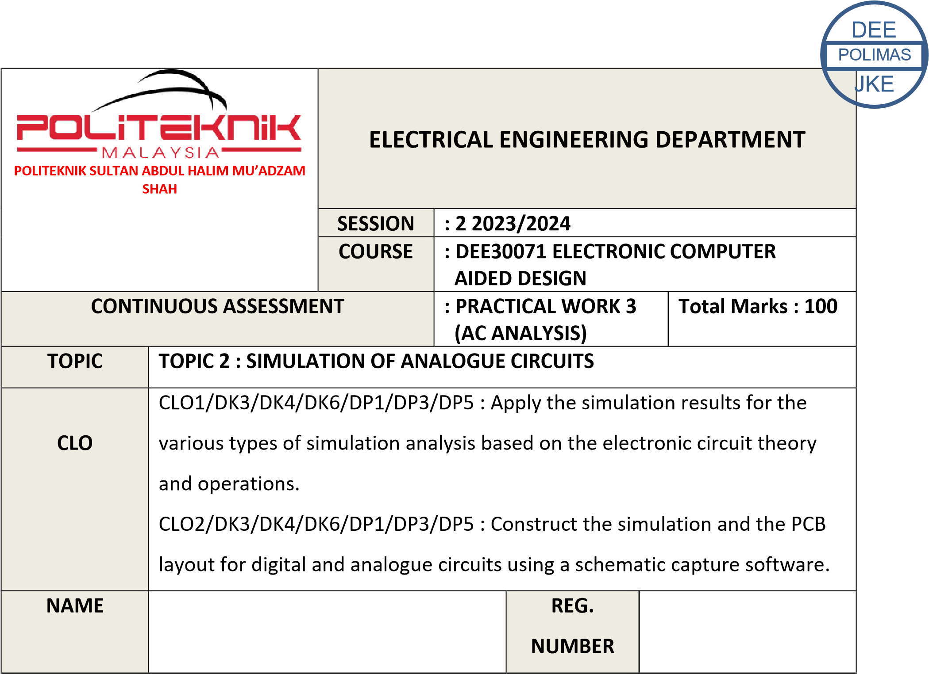

|  |  |
| --- | --- |
| **1** | **LEARNING OUTCOMES (LO):**  1 Apply the simulation results for the various types of simulation analysis based on the electronic circuit theory and operations (C3, PLO1) |
| **2** | **OBJECTIVE :**  Upon completion of this practical session, students should be able to:   1. Explain AC analysis and AC sources. 2. Do the AC analysis setup. 3. Simulate and display the simulation result for AC analysis. |
| **3** | **THEORY :**     * AC analysis is an analysis involving the use of AC sources. During this analysis, we analyze the effect of varying the input source frequency on circuit **gain**, **cut off frequency** and **bandwidth**. * In this simulation the AC source can be set at a particular frequency or within a frequency range (variable frequency). The magnitude and phase of the sine waves produced by the AC source is constant for all frequencies. The **AC sweep** analysis is the analysis used to measure the circuit performance or response to small signal AC source. * **Bode plot** or graph of the **frequency response** is another output of AC sweep.   Bode plot is a standard way of presenting frequency response. The circuit’s gain in **decibel** unit is measured and plotted against changes in the frequency of the input source.   * AC analysis is used to analyze **filter** circuits such as low pass filter, high pass filter, band pass filter and band-reject or band-stop filter. Many devices that communicate via electric signals, such as telephones, radios, televisions, and satellites employ the filter circuit. Filter is designed to pass signal with desired frequencies and reject or attenuates others. * We used VSIN and VSRC as an AC source during the analysis. |
| **4** | **EQUIPMENT / TOOLS / SOFTWARE :**   1. PC workstation 2. Related software |

|  |  |
| --- | --- |
| **5** | **PROCEDURE :**    **PART A**  Draw and simulate all the circuits in Figure 3.1 and 3.2. Sketch and label completely the frequency response curve / Bode Plot in Result section.     1. Low Pass Filter     Figure 3.1: Low Pass Filter Circuit     1. High Pass Filter     Figure 3.2 : High Pass Filter Circuit |

Setting For Figure

3

& Figure

.1

3

.2

:

Click

**Menu Bar**

, choose

**Analysis**

\

**Setup**

. Click the check box

**AC SWEEP**

to enable it

and set the specification as shown below :

AC Sweep Type : Decade

Sweep Parameters :

Pts/ Decade : 10

Start Frequency : 1

End Frequency : 100k

Save the file and simulate the circuit. Choose

**Trace>>add**

. Click

**V(**

**OUT**

**).**

Add DB infront

of V(

OUT

in

)

the Trace command.

Note : the Trace command now writen with

**VdB(OUT)**

Find the Max Gain, A (max) and the coordinat by

clicking

**Toggle Cursor,**

***CURSOR MAX***

and

***MARK LABEL***

.

Drops 3 dB from the maximum gain to get cut

-

off fr

equency (f

C

).

**PART B**

Draw and simulate the circuit in Figure

3

. Sketch the input and output

.3

waveform in Result section.

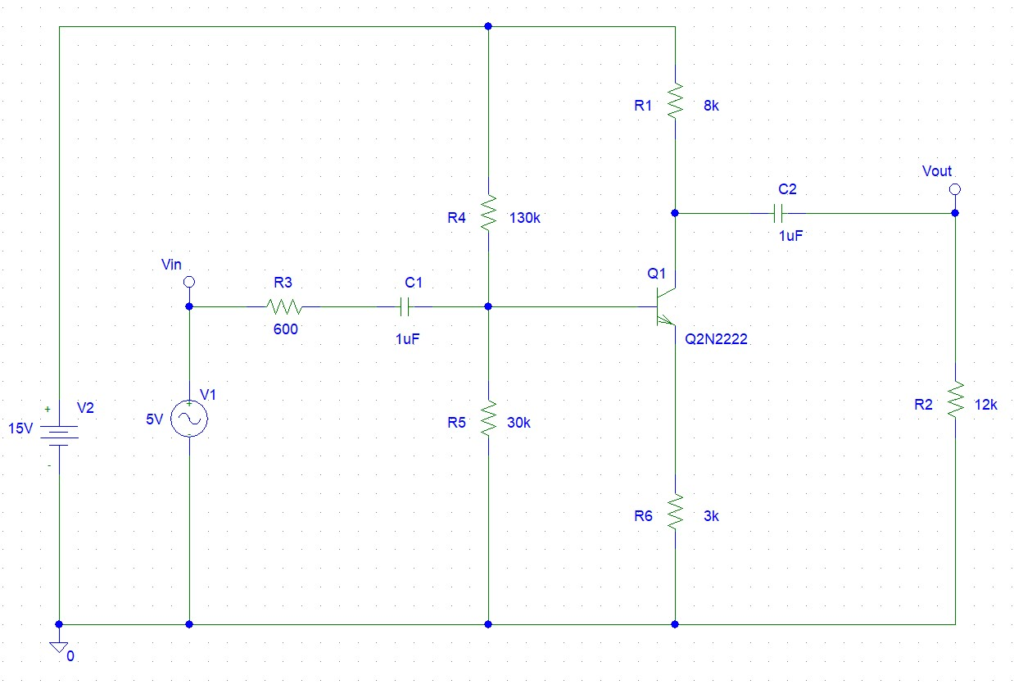

Figure

3

.3

: Amplifier Circuit

Setting for Figure 3.3 :

a.

VAC

b.

Click

**Menu Bar**

, choose

**Analysis**

\

**Setup**

. Click the check box

**AC SWEEP**

to

enable it and set the specification as shown below :

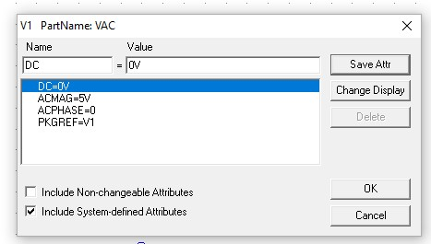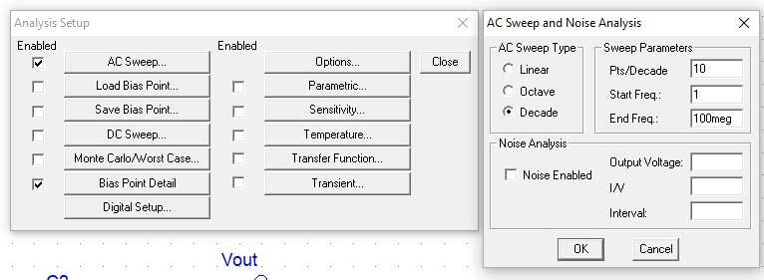

|  |  |  |  |  |  |  |  |  |  |
| --- | --- | --- | --- | --- | --- | --- | --- | --- | --- |
| **6** | **RESULT :**    **PART A**   1. Frequency response curve / Bode Plot for Figure 3.1: Low Pass Filter Circuit          |  |  | | --- | --- | | Maximum voltage gain, Av (dB). | **0** | | Cut off frequency, fc | **159.16hz** |        1. Frequency response curve / Bode Plot for Figure 3.2: High Pass Filter Circuit            |  |  | | --- | --- | | Maximum voltage gain, Av (dB). | **0** | | Cut off frequency, fc | **251.65mhz** | |

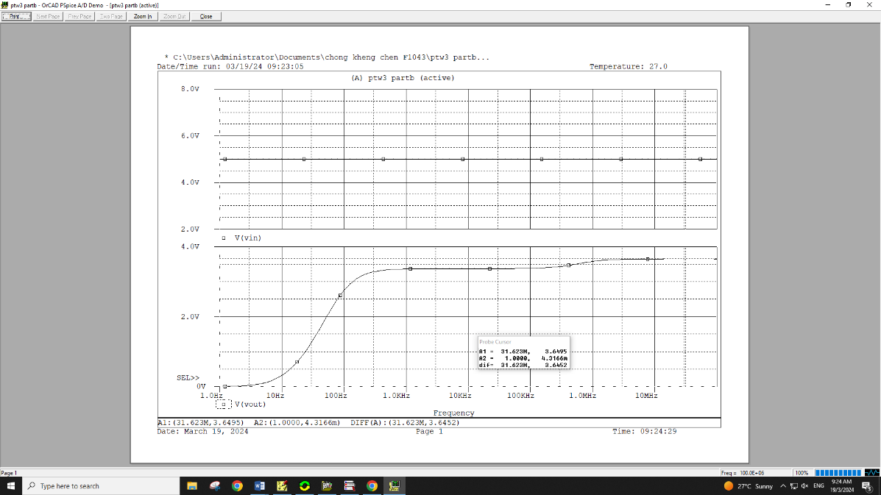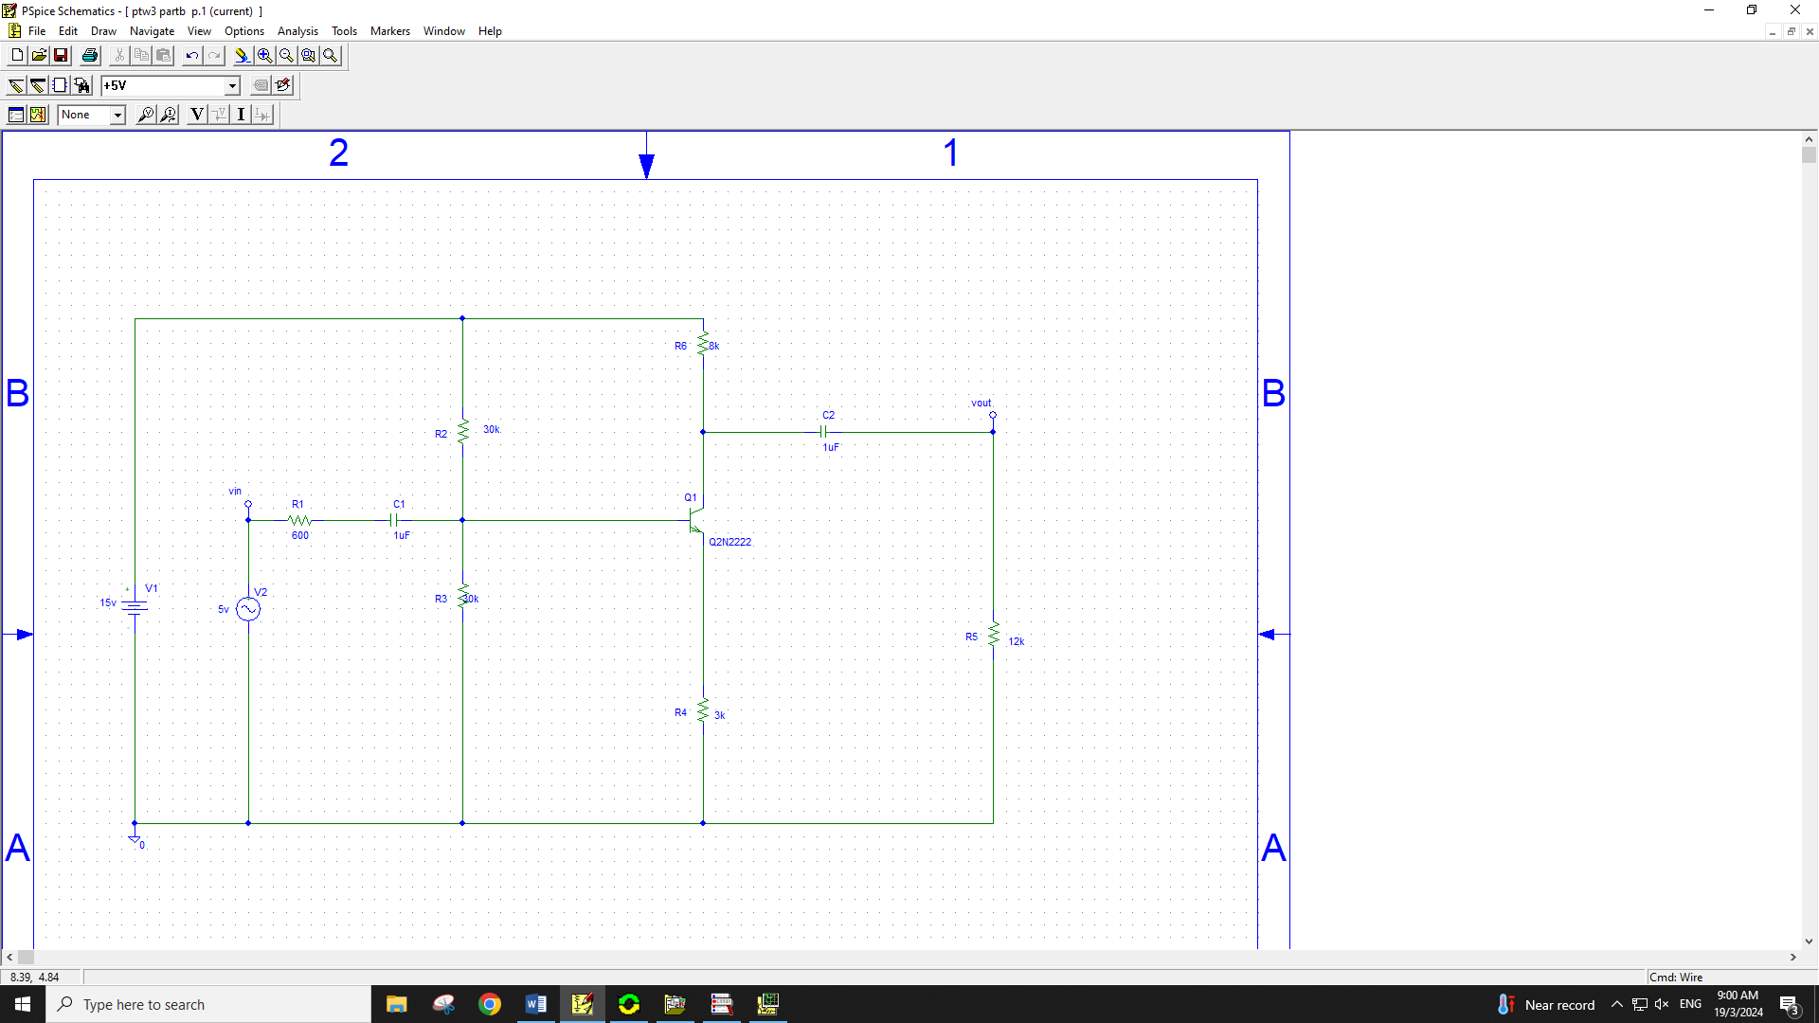

**PART B**

a. Input and output waveform for Figure

3

.3

: Amplifier Circuit

b. Calculate the Output Gain (AV)

and the bandwidth

for the circuit.

**A**

**V**

**Vout/Vin=0.73v**

**=**

**B**

**W**

**=**

**fc2**

**–**

**fc1**

|  |  |
| --- | --- |
| **7** | **DISCUSSION :**  AC analysis deals with circuits under changing currents and voltages. We use simulations to study them. Results help us understand how circuits work with alternating currents. This is important for designing and troubleshooting electronic devices. We can discuss practical examples to understand these concepts better. |
| **8** | **CONCLUSION :**  In this session, students learned about AC analysis and sources, set up AC analysis, simulated circuits, and interpreted simulation results. Now, they can design and analyze electronic circuits operating under AC conditions effectively.  ………………………………………………………………………………………………  ………………………………………………………………………………………………  ………………………………………………………………………………………………  ………………………………………………………………………………………………  ……………………………………………………………………………………………… |

|  |  |  |  |  |  |  |  |  |  |  |
| --- | --- | --- | --- | --- | --- | --- | --- | --- | --- | --- |
| **PRACTICAL WORK 3 : AC ANALYSIS** | | | | | |  |  | A |  | B |
|  | **MATRIX NUMBER** | | |  | | **NAME** |  |
| **A** | 03DET22F1043 | | | CHONG KHENG CHEN | |  |  |
| Course Learning  Outcomes(CLO)/  Learning Domain Cluster (CLS) | | Circuit | Skills /  Aspects | | Very Poor | Satisfactory | Very Good | Marks | |  |
| 1 | 2 | 3 |
| CLO 1 : Apply the simulation results for the various types of simulation analysis based on the electronic circuit theory and operations.    CLO 2: Construct the simulation and the PCB layout for digital and analogue circuits using a schematic capture software.    CLS 1:  Knowledge &  Understanding    CLS3a :  Practical skill | | PART  A    4.1 | Edit title block: Student able to edit the title block correctly. | | Able to edit the title block correctly with assistance. | Good to edit the title block correctly with minimum assistance. | Excellent to edit the title block effectively. | /3 |  | /3 |
| Draw circuit: Student able to draw the circuit same as given. | | Able to draw the circuit with assistance. | Good to draw the circuit moderately with minimum assistance. | Excellent to draw the circuit effectively. | /3 |  | /3 |
| Simulation setting: Student able to set simulation settings correctly. | | Able to set all the simulation settings correctly with assistance. | Good to set all the simulation settings correctly with minimum assistance. | Excellent to set all the simulation settings correctly and effectively. | /3 |  | /3 |
| Waveform : Student able to produce the waveform with correct axis labels and values. | | Able to produce the waveform correctly with assistance. | Good to produce the waveform correctly with minimum assistance | Excellent to produce the waveform correctly and effectively. | /3 |  | /3 |
|  | | | |  |  | /12 |  | /12 |
| PART  A    4.2 | Edit title block: Student able to edit the title block correctly. | | Able to edit the title block correctly with assistance. | Good to edit the title block correctly with minimum assistance. | Excellent to edit the title block effectively. | /3 |  | /3 |
| Draw circuit: Student able to draw the circuit same as given. | | Able to draw the circuit with assistance. | Good to draw the circuit moderately with minimum assistance. | Excellent to draw the circuit effectively. | /3 |  | /3 |
| Simulation setting: Student able to set simulation settings correctly. | | Able to set all the simulation settings correctly with assistance. | Good to set all the simulation settings correctly with minimum assistance. | Excellent to set all the simulation settings correctly and effectively. | /3 |  | /3 |
| Waveform : Student able to produce the waveform with correct axis labels and values. | | Able to produce the waveform correctly with assistance | Good to produce the waveform correctly with minimum assistance | Excellent to produce the waveform correctly and effectively. | /3 |  | /3 |
|  | | | |  |  | /12 |  | /12 |
| PART B | Edit title block: Student able to edit the title block correctly. | | Able to edit the title block correctly with assistance. | Good to edit the title block correctly with minimum assistance. | Excellent to edit the title block effectively. | /3 |  | /3 |
| Draw circuit: Student able to draw the circuit same as given. | | Able to draw the circuit with assistance. | Good to draw the circuit moderately with minimum assistance. | Excellent to draw the circuit effectively. | /3 |  | /3 |
|  | | 4.3 | Simulation setting: Student able to set simulation settings correctly. | | Able to set all the simulation settings correctly with assistance. | Good to set all the simulation settings correctly with minimum assistance. | Excellent to set all the simulation settings correctly and effectively. | /3 | /3 | |
| Waveform : Student able to produce the waveform with correct axis labels and values. | | Able to produce the waveform correctly with assistance. | Good to produce the waveform correctly with minimum assistance | Excellent to produce the waveform correctly and effectively. | /3 | /3 | |
|  |  | |  |  |  | /12 | /12 | |

# PRACTICAL SKILLS PSYCHOMOTOR ASSESMENT - (80%)

|  |  |  |  |  |  |  |
| --- | --- | --- | --- | --- | --- | --- |
| **NO.** | **STUDENT’S NAME** | **PART**  **A**    **(4.1)** | **PART**  **A**    **(4.2)** | **PART**  **B**    **(4.3)** | **Total:** | **80%** |
| **(36 marks)** |
| **A** | CHONG KHENG CHEN | /12 | /12 | /12 | /36 | /80 |

# PRACTICAL WORK COGNITIVE ASSESSMENT - (REPORT 20%)

|  |  |  |  |  |  |  |  |  |  |
| --- | --- | --- | --- | --- | --- | --- | --- | --- | --- |
|  | **PART A** | |  | **PART B** | | **Discussion** | **Conclusion** | **TOTAL** | **20**  **%** |
| a.  Plot | a.  Calculation | b.  Plot | b.  Calculation | a.  Waveform | b.  Calculation |
| /3 | /2 | /3 | /2 | /6 | /4 | /10 | /10 | /40 | /20 |

# TOTAL MARKS

|  |  |  |  |  |
| --- | --- | --- | --- | --- |
| **NO.** | **STUDENT’S NAME** | **COGNITIVE**  **ASSESSMENT**  **(20 %)** | **PSYCHOMOTOR**  **ASSESMENT**  **(80 %)** | **Total:** |
| **(100 %)** |
| **A** | CHONG KHENG CHEN | /20 | /80 | /100 |

**Notes : (PART A – after draw a schematic circuit)**

Click **Menu Bar**, choose **Analysis**\**Setup**. Click the check box **AC SWEEP** to enable it and set the specification as shown below :

AC Sweep Type : Decade

Sweep Parameters : Pts/ Decade : 10

Start Frequency : 1

End Frequency : 100k

Save the file and simulate the circuit. Choose **Trace>>add**. Click **V(Out).** Add DB infront of V(Out) in the Trace command.

Note : the Trace command now writen with **VdB(Vout)**

Find the Max Gain, A (max) and the coordinat by clicking **Toggle Cursor, *CURSOR MAX***and ***MARK LABEL***.

Drops 3 dB from the maximum gain to get cut-off frequency (fC).

**Formula :**

1. **Voltage gain Av = Vout/Vin**

1. **Critical frequency, fc = 1 / 2****RC Hz**